FINANCING COLLECTION

Screen Shots:
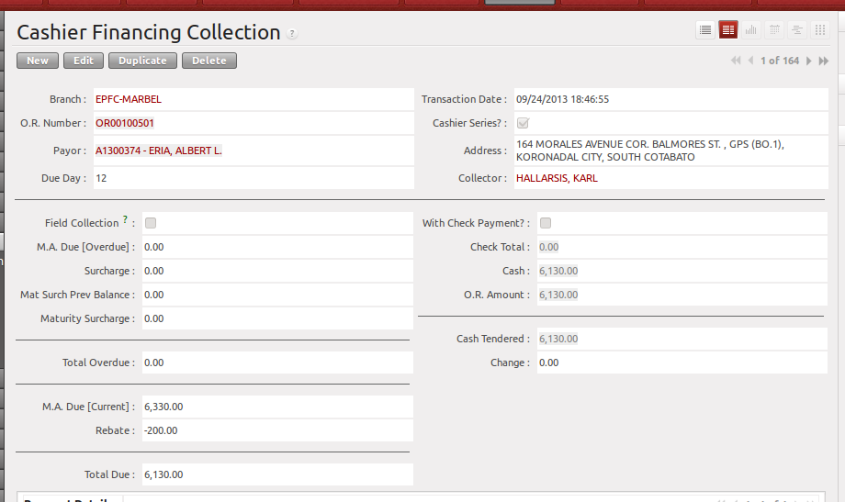
OR Number – Selection. If the OR Number is not found in the list, it is either not encoded by the Branch Accounting Assistant or the OR Number was already used. To check if the OR is already used, go to Cashiering > Receipts Inquiry.

Cashier Series – This is used to filter if the OR is issued to the cashier or not.

After payor is filled-up, it will automatically compute the due of the client.

Sample Illustration how will the Total Due be computed.

Due Day of Client : Every 1st of the month
Today is : July 2, 2013

Payment Schedule :
Month MA Due Surcharge Rebate
June 1, 2013 - 1,500.00 45.00
July 1, 2013 - 2,000.00 under grace period
August 1, 2013 - 2,000.00 200.00
Sept 1, 2013 - 2,000.00 200.00
Computation :
M.A. Overdue - 3,500.00 (June and July)
M.A. Current - 2,000.00 (August)
Rebate - 200.00 (August)
Surcharge - 45.00 (June)
Check Information
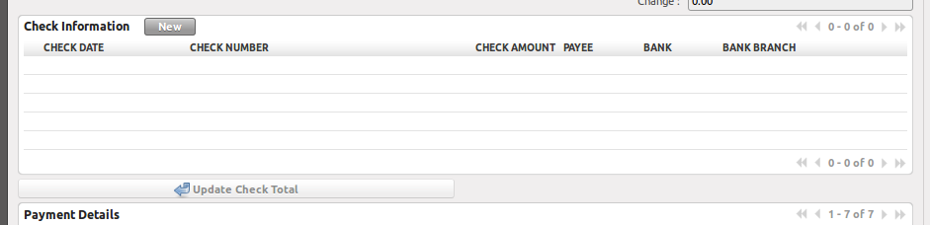
    - This will only appear if “With Check Payment” is checked.

Step 1 → Click New Button
Step 2 → Input check Details
Step 3 → Click Save Icon (diskette icon)
Step 4 → Click “Update Check Total”

Payment Details
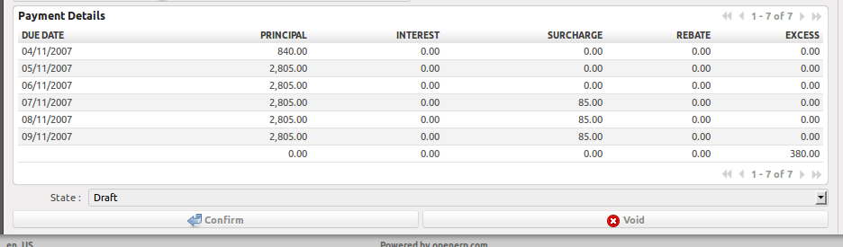
This will be automatically computed by the system.

Order of payment Application:
            - Maturity Surcharge
            - Surcharge
            - Principal
            - Excess Payment

Buttons
Confirm Button
      - Applies the breakdown to Payment Schedule
      - Generates Journal Entry
      - Changes record state to “Confirmed”
      - Updates the ledger of the client.

Void Button
- Voids the OR transaction.
- If the state of the record is not draft, it will remove the entries in the Loan Ledger. And will also void the Journal Entries of that certain document.

Validations:
    - only the OR's of the branch can be viewed by the user.
    - No rebate if “Field Collection” is checked.
    - O.R. Amount is the sum of Check Total and Cash.

